Small signal analysis of BJT circuits
- In the I_{C} and V_{out} columns enter the DC collector current and DC output voltage respectively.
- In the other columns, enter the small signal values.
- Assume an infinite Early voltage.
- On separate page(s), show your work for each problem.
- Round you answer to 2-significant figures and include units.
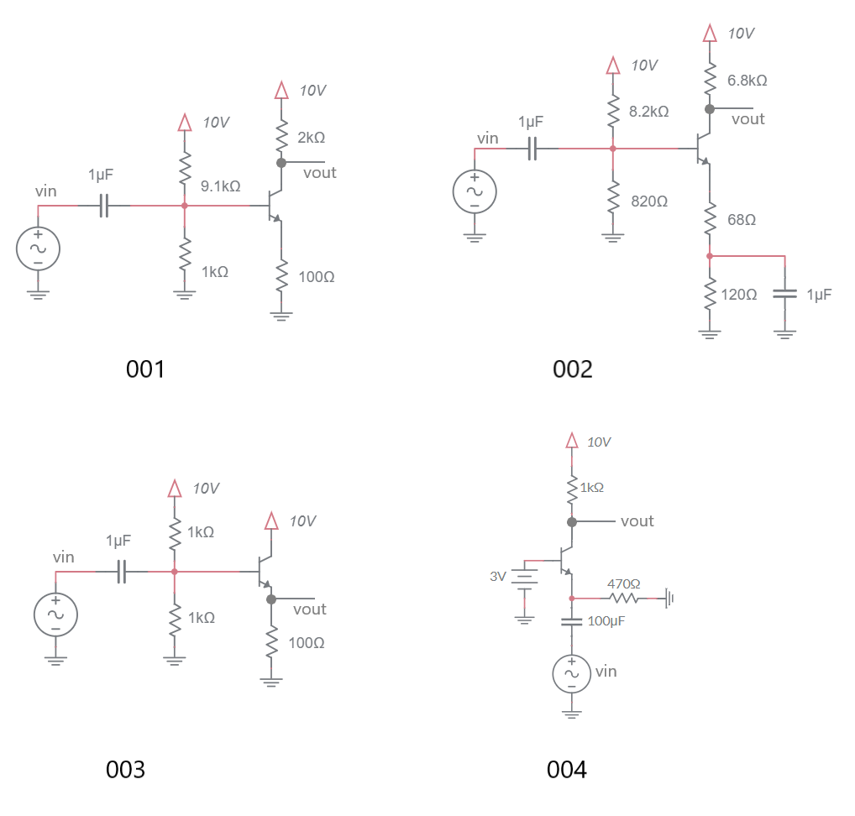

Circuit | I_{C} | V_{OUT} | g_{m} | r_{e} | A_{V}
001
002
003
004
Small signal analysis of BJT circuits
- In the I_{C} and V_{out} columns enter the DC collector current and DC output voltage respectively.
- In the other columns, enter the small signal values.
- Assume an infinite Early voltage.
- On separate page(s), show your work for each problem.
- Round you answer to 2-significant figures and include units.
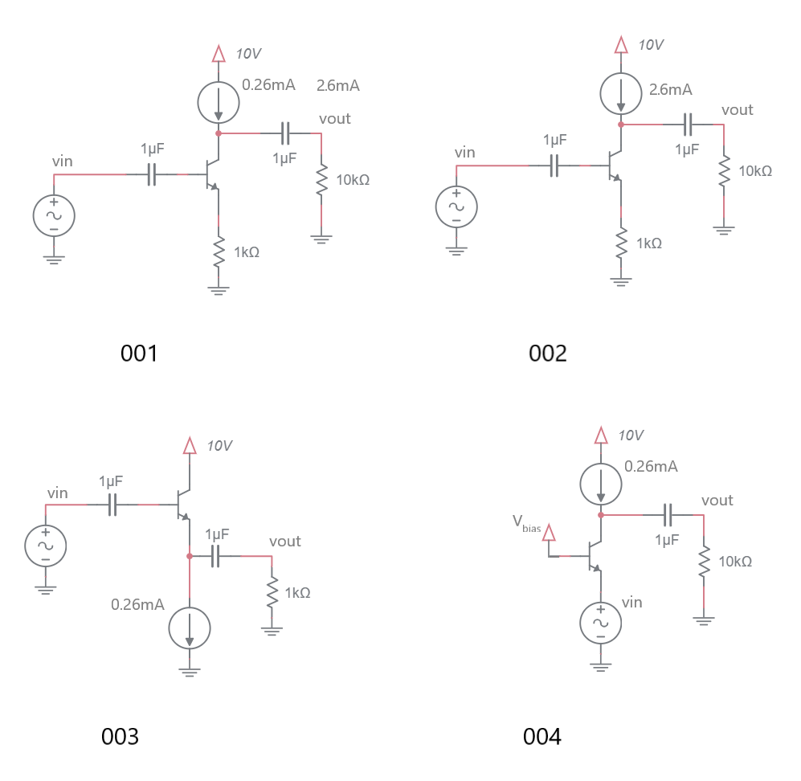
Circuit | I_{C} | V_{OUT} | g_{m} | r_{e} | A_{V}
001
002
003
004
Small signal analysis of BJT circuits
Let’s explore the range of AC gain that you can achieve with the following circuit. The values of R1 and R2 have been selected so that the base of the BJT is DC biased to 0.96V – you do not need to compute the resistors values needed to make this happen.
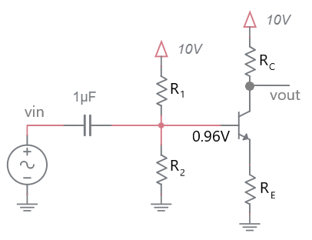
Step 1: Describe I_{C} in terms of R_{E}

Step 2: Describe V_{OUT} in terms of R_{E} and R_{C}

Step 3: Describe g_{m} and r_{e} in terms of R_{E}

Step 4: Draw a small signal model for the circuit

Step 5: Describe the small signal gain in terms of R_{E} and R_{C}

Step 6: Describe V_{OUT} in terms of A_{v}

Step 7: Find the maximum gain before the BJT saturates

Examining the input/output behavior of various amplifiers
In both of the following problems the BJT amplifier is powered by 10V and GND. The input is capacitively coupled to the amplifier (there is no issue with the input swinging to negative voltages).
  - You have built a BJT amplifier where your DC analysis of the circuit shows that Vout sits at 5V. Your AC analysis shows that your circuit has a gain of -2. Given the input waveform shown, draw the output.
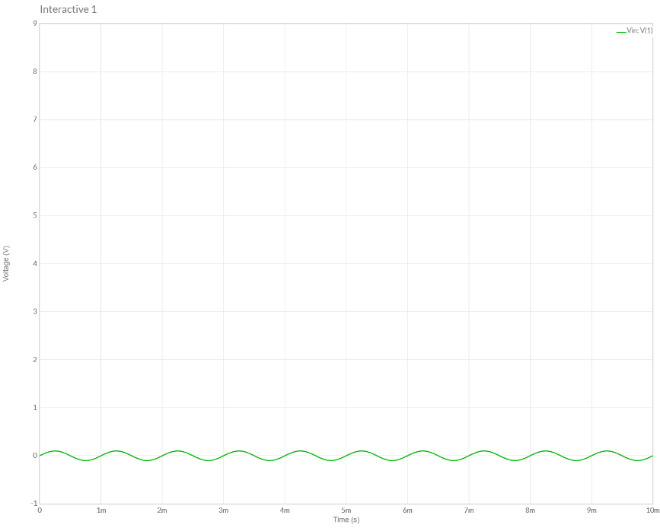

  - You have built a BJT amplifier where your DC analysis of the circuit shows that Vout sits at 5V. Your AC analysis shows that your circuit has a gain of 6. Given the input waveform shown, draw the output.

